Hiralben Prajapati – Assignment 4
Battery degradation occurs mainly due to usage habits, environmental conditions and natural aging over time. (See figure 1)
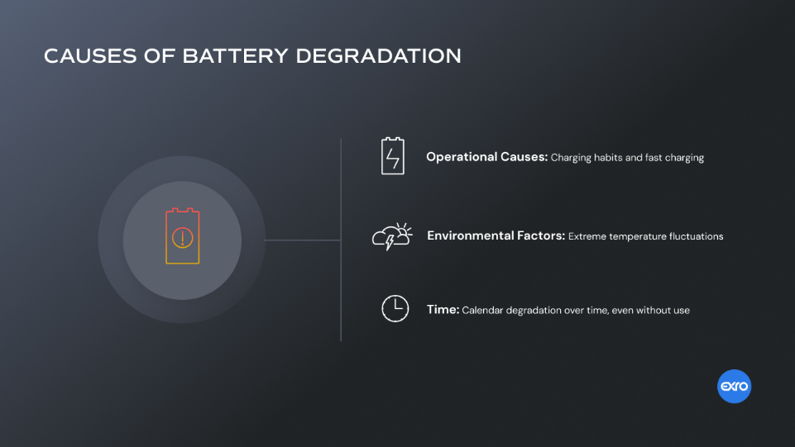
Figure 1 : battery degradation [1]

Battery resistance increases as batteries age or develop faults. (See table 1)
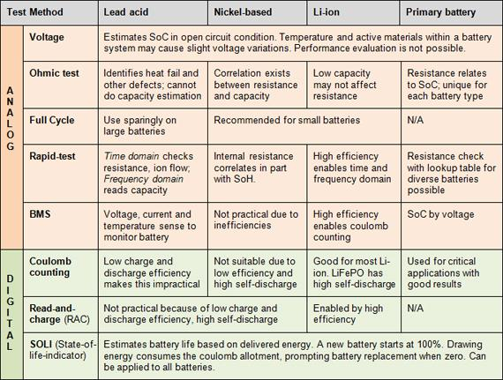
Table 1: Battery test methods for common batteries. [2]
Figure 1 : battery degradation [1] 1

Table 1: Battery test methods for common batteries. [2] 1

Bibliography

[1] | "Battery Degradation," [Online]. Available: https://www.exro.com/industry-insights/battery-degradation-explained. [Accessed 10 February 2026].
[2] | "Battery test methods," [Online]. Available: https://www.batteryuniversity.com/article/battery-test-methods/. [Accessed 10 February 2026].

